Frameworx Technical Report

TM Forum Information Framework Enhancements to Support ZOOM

TR244
Release 15.0.1
February 2016

Latest Update: Frameworx Release 15 | TM Forum Approved
Version 1.0.3 | IPR Mode: RAND

Notice

Copyright © TM Forum 2016. All Rights Reserved.

This document and translations of it may be copied and furnished to others, and derivative works that comment on or otherwise explain it or assist in its implementation may be prepared, copied, published, and distributed, in whole or in part, without restriction of any kind, provided that the above copyright notice and this section are included on all such copies and derivative works. However, this document itself may not be modified in any way, including by removing the copyright notice or references to TM FORUM, except as needed for the purpose of developing any document or deliverable produced by a TM FORUM Collaboration Project Team (in which case the rules applicable to copyrights, as set forth in the TM FORUM IPR Policy, must be followed) or as required to translate it into languages other than English.

The limited permissions granted above are perpetual and will not be revoked by TM FORUM or its successors or assigns.

This document and the information contained herein is provided on an "AS IS" basis and TM FORUM DISCLAIMS ALL WARRANTIES, EXPRESS OR IMPLIED, INCLUDING BUT NOT LIMITED TO ANY WARRANTY THAT THE USE OF THE INFORMATION HEREIN WILL NOT INFRINGE ANY OWNERSHIP RIGHTS OR ANY IMPLIED WARRANTIES OF MERCHANTABILITY OR FITNESS FOR A PARTICULAR PURPOSE.

TM FORUM invites any TM FORUM Member or any other party that believes it has patent claims that would necessarily be infringed by implementations of this TM Forum Standards Final Deliverable, to notify the TM FORUM Team Administrator and provide an indication of its willingness to grant patent licenses to such patent claims in a manner consistent with the IPR Mode of the TM FORUM Collaboration Project Team that produced this deliverable.

The TM FORUM invites any party to contact the TM FORUM Team Administrator if it is aware of a claim of ownership of any patent claims that would necessarily be infringed by implementations of this TM FORUM Standards Final Deliverable by a patent holder that is not willing to provide a license to such patent claims in a manner consistent with the IPR Mode of the TM FORUM Collaboration Project Team that produced this TM FORUM Standards Final Deliverable. TM FORUM may include such claims on its website, but disclaims any obligation to do so.

TM FORUM takes no position regarding the validity or scope of any intellectual property or other rights that might be claimed to pertain to the implementation or use of the technology described in this TM FORUM Standards Final Deliverable or the extent to which any license under such rights might or might not be available; neither does it represent that it has made any effort to identify any such rights. Information on TM FORUM's procedures with respect to rights in any document or deliverable produced by a TM FORUM Collaboration Project Team can be found on the TM FORUM website. Copies of claims of rights made available for publication and any assurances of licenses to be made available, or the result of an attempt made to obtain a general license or permission for the use of such proprietary rights by implementers or users of this TM FORUM Standards Final Deliverable, can be obtained from the TM FORUM Team Administrator. TM FORUM makes no representation that any information or list of intellectual property rights will at any time be complete, or that any claims in such list are, in fact, Essential Claims.

Direct inquiries to the TM Forum office:

240 Headquarters Plaza,
East Tower – 10th Floor,
Morristown, NJ 07960 USA
Tel No. +1 973 944 5100
Fax No. +1 973 944 5110
TM Forum Web Page: www.tmforum.org

Table of Contents
Notice ……………………………………………………………………………………………………………………2
Table of Contents 4
Table of Figures 7
Table of Tables 8
Executive Summary 9
1. Introduction 10
1.1. Document Structure 10
1.1.1. Introduction 10
1.1.2. Appendices 10
1.2. Terminology Used Within This Document 11
2. Information Model Classes to be Integrated 12
2.1. VirtualResource 12
2.1.1. Problem Statement 12
2.1.2. Proposed Resolution 12
2.1.3. New Class Definitions 14
2.1.3.1. ManagedResource 14
2.1.3.2. VirtualResource 14
2.1.3.3. NetworkFunction 14
2.1.4. Example 14
2.2. NetworkFunction 15
2.2.1. Problem Statement 15
2.2.2. Proposed Resolution 15
2.2.3. New Class Definitions 16
2.2.3.1. NetworkFunction 16
2.2.3.2. NetworkFunctionComposite 16
2.2.3.3. NetworkFunctionAtomic 17
2.2.3.4. VNF 17
2.2.3.5. VNFC 17
2.2.3.6. PNF 17
2.2.3.7. NetworkFunctionState 17
2.2.3.8. NFTransferFunction 17
2.2.4. New Association Definitions 17
2.2.4.1. HasNFs 17
2.2.4.2. NFHasState 18
2.2.4.3. NFDefinedBy 18
2.2.4.4. ProvidesVirtualResourceFor 18
2.2.4.5. ProvidesPhysicalResourceFor 18
2.2.4.6. ProvidesLogicalResourceFor 18
2.2.4.7. ProvidesVirtualHostingFor 18
2.2.4.8. ProvidesPhysicalHostingFor 18
2.2.5. Example 18
2.3. NetworkService 20
2.3.1. Problem Statement 20
2.3.2. Proposed Resolution 20
2.3.3. New Class Definitions 20
2.3.3.1. NetworkService 21
2.3.3.2. NetworkServiceComposite 21
2.3.3.3. NetworkServiceAtomic 21
2.3.3.4. NetworkFunction 21
2.3.4. New Association Definitions 21
2.3.4.1. HasNSs 21
2.3.4.2. NSRequiresNF 21
2.3.4.3. RFSRequiresNS 21
2.3.4.4. CFSRequiresNS 21
2.3.5. Modified Existing Association 21
2.3.5.1. CFServiceRequiresRFService 21
2.3.6. Example 22
2.4. Graphs 23
2.4.1. Problem Statement 23
2.4.2. Proposed Resolution 23
2.4.3. Graph Proposal Within the Topology ABE 23
2.4.4. Using Graphs to Model Forwarding Graphs 24
2.4.5. New Class Definitions 25
2.4.5.1. Graph 26
2.4.5.2. Vertex 26
2.4.5.3. DirectedEdge 26
2.4.5.4. AdjacencyGraph 26
2.4.5.5. ConnectivityGraph 26
2.4.5.6. FowardingGraph 26
2.4.5.7. NFInternalTopology 26
2.4.6. New Association Definitions 27
2.4.6.1. GraphHasVertices 27
2.4.6.2. GraphHAsDirectedEges 27
2.4.6.3. DirectedEdgeCanBeDecomposedIntoSubgraph 27
2.4.6.4. VertexCanBeDecomposedIntoSubgraph 27
2.4.6.5. DirectedEdgeConnectsFromVertices 27
2.4.6.6. DirectedEdgeConnectsToVertices 27
2.4.6.7. IsAGraphDirectedEdge 27
2.4.6.8. IsAGraphVertex 27
2.4.6.9. CGSupportsAG 27
2.4.6.10. NSHasForwardingGraph 27
2.4.6.11. NFHasInternalTopology 27
2.4.7. Example 28
2.5. Catalog 30
2.5.1. Problem Statement 30
2.5.2. Constraints 30
2.5.3. Proposed resolution 30
2.5.4. Current Frameworx Model 30
2.5.5. Enhanced Frameworx Model 32
2.5.5.1. Step 1: Adding the Ability to Add and Remove Catalog Items 32
2.5.5.2. Step 2: Adding the Ability to Manage Catalog Content Using Policy Rules 32
2.5.5.3. Step 3: Adding the Ability to Dynamically Define Types of Catalogs 33
2.5.5.4. Step 4: Adding the Ability to Dynamically Define Types of Catalog Content 35
2.5.6. New Class Definitions 36
2.5.6.1. CatalogItem 36
2.5.6.2. CatalogDecorator 36
2.5.6.3. ConcreteCatalog 37
2.5.6.4. CatalogItemDecorator 37
2.5.6.5. ConcreteCatalogItem 37
2.5.7. New Association Definitions 37
2.5.7.1. GovernsCatalogItems 37
2.5.7.2. GovernsDecoratedCatalogs 37
2.5.7.3. GovernsDecoratedCatalogItems 37
2.5.7.4. CatalogItemDetails 38
2.5.7.5. DecoratedCatalogDetails 38
2.5.7.6. DecoratedCatalogItemDetails 38
2.5.8. Examples 38
2.5.8.1. Creating a VNFCatalog 38
2.5.8.2. Dynamic NFV Catalog Federation 38
2.5.9. Summary 39
2.6. Event 40
2.6.1. Problem Statement 40
2.6.2. Background 40
2.6.2.1. Event Definition 40
2.6.2.2. Event Usage 40
2.6.3. Requirements of the Event Model 40
2.6.4. Proposed Resolution 41
2.6.5. New Class Definitions 42
2.6.5.1. EventOccurrence 42
2.6.5.2. EventRecord 42
2.6.5.3. EventRecordComposite 43
2.6.5.4. EventRecordAtomic 43
2.6.5.5. EventRecordPayload 43
2.6.6. New Association Definitions 43
2.6.6.1. HasEventRecords 43
2.6.6.2. EventRecordPayload 43
2.6.6.3. EventRecordPayload 43
2.6.7. Examples 43
2.6.7.1. Events That Do Not Need Additional Information 43
2.6.7.2. Events That Do Need Additional Information 44
2.6.8. Summary 44
Appendix A: The Single Responsibility Principle 45
Appendix B: Decorator Pattern Examples 46
Appendix C: List of References Used in This Document 47
Appendix D: Administrative Information 48
Appendix D.1. Administrative Information 48
Appendix D.2. Release History 48
Appendix D.3. Company Contact Details 49

Table of Figures
Figure 1. Introduction of the VirtualResource Class 13
Figure 2. Introduction of the NetworkFunction Class Hierarchy 15
Figure 3. NetworkFunction Does Not Affect LogicalResource 16
Figure 4. Instance Model of a Physical Firewall 19
Figure 5. Instance Model of a Virtual Firewall 19
Figure 6. Introduction of the NetworkService Hierarchy 20
Figure 7. Introduction of the NetworkService Hierarchy 22
Figure 8. Introduction of the NetworkService Hierarchy 22
Figure 9. Introduction of the NetworkService Hierarchy 23
Figure 10. Subclasses of the Graph Class 24
Figure 11. AdjacencyGraph, as Used by NetworkService and NetworkFunction 25
Figure 12. AdjacencyGraph, as Used by NetworkService and NetworkFunction 29
Figure 13. Existing Frameworx Catalog Model 31
Figure 14. Enhanced Catalog Model. 32
Figure 15. Using PolicyRules to Govern CatalogItems 33
Figure 16. Using the Decorator Pattern to Dynamically Add New Catalog Types 34
Figure 17. Catalog Decorators 35
Figure 18. CatalogItems Decorators 36
Figure 19. Federated dynamic NFV Catalogs (high level architecture) 39
Figure 20. Event Model 42

Table of Tables
Table 1. Acronyms Used in This Document 11

Executive Summary
This document describes a portion of the ZOOM information model, which has been integrated into the Information Framework. It defines four concepts fundamental to modeling NFV-based systems (VirtualResource, NetworkFunction, NetworkService, and Graph), as well as two general-purpose concepts (Catalog and Event) that have been used by existing Catalysts, and are also critical for realizing SDN and NFV systems. The six major concepts that are defined in this document, and their uses, are:
- VirtualResource: a concept for modeling MangedResources that have been virtualized
NetworkFunction: a functional block, from a systems point-of-view, which has well-defined inputs,
outputs, state, and whose behavior is defined by a transfer function
NetworkService: a composition of NetworkFunctions and defined by its functional and
behavioral specification
Graph: a topological construct composed of a set of vertices connected by directed
edges
Catalog: an alternate to the existing Catalog model that can support dynamically defined
types of Catalogs and types of CatalogItems
Event: a model that supports event-driven programming

Introduction
This document defines a subset of the ZOOM information model that has been integrated with the Information Frameworx 15.0. This contribution is aimed at work item 4.3 of the ZOOM WG charter [1].
This integration enables the TM Forum to respond in a timely manner to new operator needs caused by SDN and NFV, as well as other new industry initiatives (e.g., [2] - [6]).

Document Structure
This version of this document describes how concepts from the ZOOM information model can be integrated into the Frameworx 15.0 model. It is a companion document to the ZOOM Frameworx submission.

Introduction
Executive Summary: This document describes a portion of the ZOOM information model, which has been integrated into the Information Framework. It defines four concepts fundamental to modeling NFV-based systems (VirtualResource, NetworkFunction, NetworkService, and Graph), as well as two general-purpose concepts (Catalog and Event) that have been used by existing Catalysts, and are also critical for realizing SDN and NFV systems.
Section 1: This section outlines the structure of, and defines essential terms used in, this document.
Section 2: This section describes the six new structures (classes and associations) of the ZOOM model
that are being integrated into the Information Frameworx. It also provides class and
association definitions, as well as associated examples.

Appendices
Appendix A The Single Responsibility Principle
Appendix B Decorator Pattern Examples
Appendix C List of References Used in This Document
Appendix D Administrative Information

Terminology Used Within This Document
This section identifies the important terms, abbreviations and acronyms introduced by the project and are necessary for the understanding of this document.
The following acronyms are used in this document.

Table 1. Acronyms Used in This Document
Acronym | Definition
CR | Change Request
FCAPS | Fault, Configuration, Accounting, Performance, Security (operations)
GS | General Specification (used in ETSI NFV)
MANO | Management and Network Orchestration (a sub-group of ETSI NFV)
MEF | Metro Ethernet Forum
NFV | Network Functions Virtualization (an ETSI ISG)
NFVI | Network Functions Virtualization Infrastructure
NFVO | NFV Orchestrator (part of the MANO architecture)
ONF | Open Networking Foundation
PNF | Physical Network Function
SDN | Software Defined Networking
SDO | Standards Defining Organization
VIM | Virtualization Infrastructure Manager (part of the MANO architecture)
VM | Virtual Machine
VNF | Virtual Network Function
VNFM | VNF Manager (part of the MANO architecture)
WG | Working Group

Information Model Classes to be Integrated
The following defines the subset of information model classes defined in the ZOOM project that will be integrated into the Frameworkx 15.0 project.

VirtualResource
This section introduces the addition of VirtualResource to Frameworx. It also covers two additional classes that directly interact with VirtualResource, which are ManagedResource (its superclass) and NetworkFunction (one of its siblings); NetworkFunction is further defined in Section 2.2.

Problem Statement
The key concept within NFV is to virtualize network functions. In order to do so, it introduces the notion of virtualization of the compute, storage and networking functions of the infrastructure.
The TM Forum Information model is "competing" within the NFV definition with other models (Yang, TOSCA, etc...), not only on its technical merits, but also in terms of adoption and momentum.
It is therefore absolutely critical that the notion of virtualization be explicitly modeled and that a first class citizen (an entity) represents such a concept.

Proposed Resolution
The proposed solution is to create a new entity called the VirtualResource derived from the Resource hierarchy as illustrated by the following diagram. The three classes shown within the dashed rectangle are the three classes that are part of the VirtualResource model, and are described in the following subsections.
A VirtualResource is the result of applying one or more Software Processes to a ManagedResource to create one or more new ManagedResources whose assets (e.g., memory) and services (e.g., networking) can be shared among multiple, possibly heterogeneous, consumers. Put another way, a VirtualResource is an abstraction that decouples the physical manifestation and delivery of a Resource from its logical operation. In particular, a VirtualResource could be used in conjunction with a virtualization process to create virtual compute, virtual network, and virtual storage. A virtualized CPU is an example of VirtualResource. A VirtualResource must be hosted by a PhysicalResource and can (but does not have to) be packaged as part of a Product.

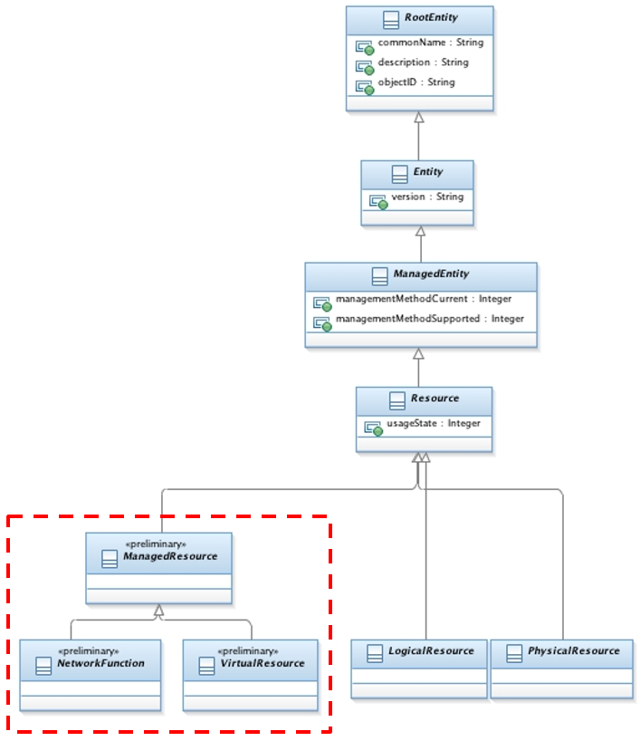
Figure 1. Introduction of the VirtualResource Class

New Class Definitions
This section provides definitions for all new classes introduced in the ZOOM model.

ManagedResource
The properties and description of a ManagedResource are as follows:
Properties: preliminary, Abstract
Description: A ManagedResource is an entity that is manageable by electronic means. It produces and/or consumes other ManagedResources and/or Services, and has a distinct state. A ManagedResource may be a simple concept, such as a logical point of communication, or a complex concept, such as an Application or System.

VirtualResource
The properties and description of a VirtualResource are as follows:
Properties: preliminary, Abstract
Description: VirtualResource is the result of applying within the virtualization infrastructure one or more Software Processes to a ManagedResource to create one or more new ManagedResources whose assets (e.g., memory) and services (e.g., networking) can be shared among multiple, possibly heterogeneous, consumers. Existing LogicalResources are not affected by the introduction of the VirtualResourceClass. The VirtualResource Class shall only represent virtualization provided by the infrastructure such as vCPU, vNIC, etc.

NetworkFunction
This is defined in Section 2.2.

Example
The following example is extracted from TR234, section 3.1.4.3 [8], and is an example of the model that represents a physical firewall and a virtual firewall.
The functional aspect of the firewall are modeled as a set of LogicalResources. In this approach, the ports exposed by the firewall function, as well as the filtering occurring between those ports, are modeled. However, the modeling of the non-functional aspect of the firewall depends on whether the firewall function is realized as a physical firewall or a virtualized firewall. The important thing to conInformation Frameworker is that the functional aspect of the firewall is unaffected.
In the case of a physical firewall, a set of PhysicalResources are used to represent the underlying hardware that provides hosting / implementation for the LogicalResources. In particular, the firewall ports would be hosted by a PhysicalResource that represents the actual NIC.
In the case of a virtualized firewall, there is one additional layer of abstraction: the PhysicalResources are abstracted as virtual resources. Note that the set of LogicalResources does not change.
The key difference is the non-functional aspect of the firewall. There may be some parameters — for example, affinity rules, or elasticity rules — that appear for the virtualized firewall but not the physical one . Such parameters would be expressed as attributes or associations of the VirtualResources. Taking again the same example of the firewall ports, they would be hosted by a VirtualResource representing the vNIC, itself representing the virtualization of the NIC and hosted by the PhysicalResource representing the actual NIC. Note also that if the virtual firewall is migrated to a new PhysicalResource, and a different type of virtualization is used, the resulting virtual firewall’s non-functional aspects may change as a result.

NetworkFunction
This section introduces the addition of NetworkFunction to Frameworx.

Problem Statement
Amongst other concepts, ETSI NFV has introduced the notion of Virtual Network Function (VNF) as a central concept for NFV.
NFV being a key technology to achieve the objective of a fully orchestrated network of ZOOM, it is absolutely necessary that a concept like the VNF is properly modeled.
One key value of the information model framework, beyond its technical capabilities relies in its level of adoption.
The TM Forum Information model is "competing" within the NFV definition with other models (Yang, TOSCA, etc...) not only on its technical merits but also in terms of adoption and momentum.
It is therefore absolutely critical that the notion of VNF be explicitly modeled and that a first class citizen (an entity) represents such a concept.

Proposed Resolution
The proposed solution is to create a new entity called the NetworkFunction (itself can be derived into a VNF or a PNF) as shown in the following diagram.
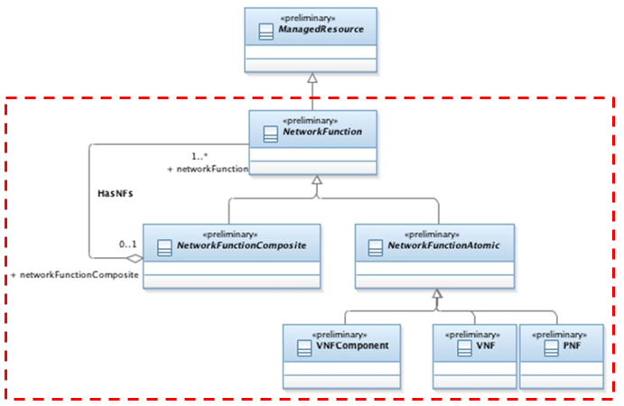
Figure 2. Introduction of the NetworkFunction Class Hierarchy
Since the installed base is an important value of the information model framework, this proposal does not change the way that the applicative part of the NetworkFunction is modeled using LogicalResources, as illustrated in the following diagram:

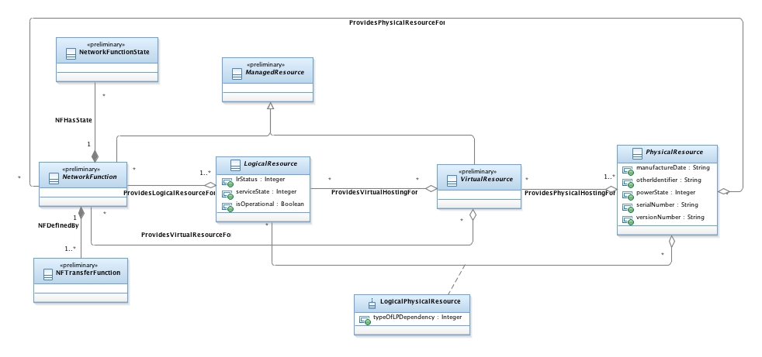
Figure 3. NetworkFunction Does Not Affect LogicalResource

New Class Definitions
This section provides definitions for all new classes in the NetworkFunction hierarchy that are introduced in the ZOOM model.

NetworkFunction
The properties and description of a CatalogItem are as follows:
Properties: preliminary, Abstract
Description: A NetworkFunction is a Functional Block (FB) within a network infrastructure that has well-defined external interfaces and well-defined functional behavior. In software and systems engineering, an FB defines a system component as a block diagram that describes the characteristics, behavior, and relationships of the system component to the rest of the system.

NetworkFunctionComposite
The properties and description of a NetworkFunctionComposite are as follows:
Properties: preliminary, Abstract
Description: A NetworkFunctionComposite is a collection of Atomic and Composite NetworkFunctions.

NetworkFunctionAtomic
The properties and description of a NetworkFunctionAtomic are as follows:
Properties: preliminary, Abstract
Description: A NetworkFunctionAtomic is a NetworkFunction that is not further decomposed into finer grained NetworkFunctions. It can therefore be used as a stand-alone entity.

VNF
The properties and description of a VNF (VirtualNetworkFunction) are as follows:
Properties: preliminary, Concrete
Description: A VNF is an implementation of a NetworkFunction for which all the LogicalResources it is being provided are hosted by VirtualResources.

VNFC
The properties and description of a VNFC (VNFComponent) are as follows:
Properties: preliminary, Concrete
Description: A Virtualised NetworkFunction Component (VNFC) is an internal component of a VNF providing a defined subset of that VNF's functionality.

PNF
The properties and description of a PNF (PhysicalNetworkFunction) are as follows:
Properties: preliminary, Concrete
Description: A PNF is an implementation of a NetworkFunction for which all the LogicalResources it is being provided are hosted directly by PhysicalResources.

NetworkFunctionState
The properties and description of a NetworkFunctionState are as follows:
Properties: preliminary, Concrete
Description: A NetworkFunctionState represents the concept of the internal state of a NetworkFunction as defined by a SysML state machine.

NFTransferFunction
The properties and description of an NFTransferFunction are as follows:
Properties: preliminary, Concrete
Description: An NFTransferFunction represents the concept of processing a set of inputs to produce a set of outputs given a particular state as defined by SysML.

New Association Definitions
This section provides definitions for all new associations in the NetworkFunction hierarchy that are introduced in the ZOOM model.

HasNFs
This association expresses the fact that a NetworkFunctionComposite is an aggregation of NetworkFunctions.

NFHasState
This association expresses the fact that a NetworkFunction, when considered as a SysML Functional Block, has an internal state that can be represented by one or more internal state variables.

NFDefinedBy
This association expresses the fact that a NetworkFunction, when considered as a SysML functional Block, has one or more transfer functions between its inputs, states and outputs.

ProvidesVirtualResourceFor
This association represents the set of VirtualResources supporting the NetworkFunction. Put another way, the behavior of this set of VirtualResources is described by this set of NetworkFunctions.

ProvidesPhysicalResourceFor
This association represents the set of PhysicalResources supporting the NetworkFunction.

ProvidesLogicalResourceFor
This association represents the set of LogicalResources implementing the NetworkFunction.

ProvidesVirtualHostingFor
This association represents the set of VirtualResources that are hosting a LogicalResource.

ProvidesPhysicalHostingFor
This association represents the set of PhysicalResources that are hosting a VirtualResource.

Example
The following is an example of the model that represents a physical firewall and a virtual firewall. The functional aspect of the firewall are modeled as a set of LogicalResources. In this approach, the ports exposed by the firewall function, as well as the filtering occurring between those ports, are modeled. However, the modeling of the non-functional aspect of the firewall depends on whether the firewall function is realized as a physical firewall or a virtualized firewall. The important thing to Information Frameworker is that the functional aspect of the firewall is unaffected. In the case of a physical firewall, a set of PhysicalResources are used to represent the underlying hardware that provides hosting / implementation for the LogicalResources. In particular, the firewall ports would be hosted by a PhysicalResource that represents the actual NIC. In the case of a virtualized firewall, there is one additional layer of abstraction: the PhysicalResources are abstracted as virtual resources. Note that the set of LogicalResources and their associations represented in red does not change. The key difference is the non-functional aspect of the firewall. There may be some parameters — for example, affinity rules, or elasticity rules — that appear for the virtualized firewall but not the physical one . Such parameters would be expressed as attributes or associations of the VirtualResources. Taking again the same example of the firewall ports, they would be hosted by a VirtualResource representing the vNIC, itself representing the virtualization of the NIC and hosted by the PhysicalResource representing the actual NIC. Note also that if the virtual firewall is migrated to a new PhysicalResource, and a different type of virtualization is used , the resulting virtual firewall’s non-functional aspects may change as a result.
Physical firewall (note that the parts in the grey box are example instantiation of the model and not part of the Information Framework) is shown below:
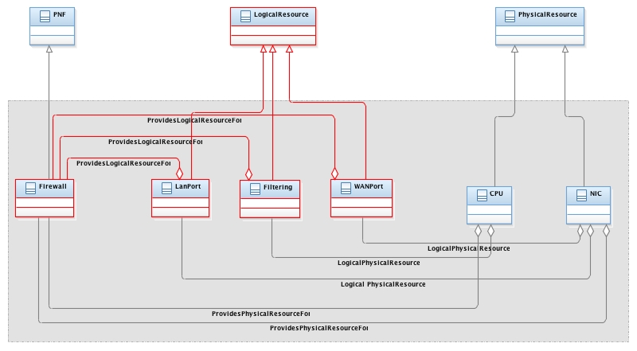
Figure 4. Instance Model of a Physical Firewall
Virtualized firewall (note that the parts in the grey box are example instanciation of the model and not part of the Information Framework) is shown below:
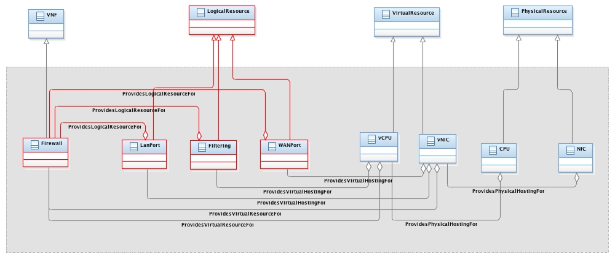
Figure 5. Instance Model of a Virtual Firewall

NetworkService
This section introduces the addition of the NetworkService hierarchy to Frameworx.

Problem Statement
Amongst other concepts, ETSI NFV has introduced the notion of Network Service as a central concept for NFV.
NFV being a key technology to achieve the objective of a fully orchestrated network of ZOOM, it is absolutely necessary that a concept like the Network Service is properly modeled.
One key value of the information model framework, beyond its technical capabilities relies in its level of adoption.
The TM Forum Information model is "competing" within the NFV definition with other models (Yang, TOSCA, etc...) not only on its technical merits but also in terms of adoption and momentum.
It is therefore absolutely critical that the notion of Network Service be explicitly modeled and that a first class citizen (an entity) represents such a concept.

Proposed Resolution
The proposed solution is to create a new entity called the NetworkService derived from Service.
Details of the proposal are in TR234, section 3.6 [8]. The key concept is illustrated in the following diagram.
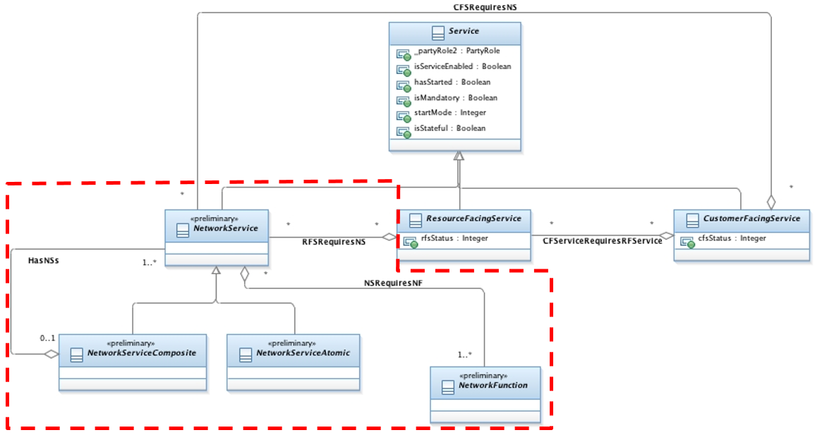
Figure 6. Introduction of the NetworkService Hierarchy

New Class Definitions
This section provides definitions for all new classes in the NetworkService hierarchy that are introduced in the ZOOM model.

NetworkService
The properties and description of a NetworkService are as follows:
Properties: preliminary, Abstract
Description: A NetworkService is a composition of NetworkFunctions and defined by its functional and behavioral specification.

NetworkServiceComposite
The properties and description of a NetworkServiceComposite are as follows:
Properties: preliminary, Abstract
Description: A NetworkServiceComposite is collection of Atomic and Composite NetworkServices

NetworkServiceAtomic
The properties and description of a NetworkServiceAtomic are as follows:
Properties: preliminary, Abstract
Description: A NetworkServiceAtomic is a NetworkService that is not further decomposed into finer grained NetworkServices.

NetworkFunction
Please refer to Section 2.2.

New Association Definitions
This section provides definitions for all new associations in the NetworkService hierarchy that are introduced in the ZOOM model.

HasNSs
This association expresses the fact that a NetworkServiceComposite is an aggregation of NetworkServices.

NSRequiresNF
This association expresses the aggregation of NetworkFunctions into a NetworkService. Put another way, this aggregation defines the set of NetworkFunctions that describe the behavior of this set of NetworkServices.

RFSRequiresNS
This association expresses the aggregation of the NetworkServices supporting a ResourceFacingService.

CFSRequiresNS
This association expresses the aggregation of the NetworkServices supporting a CustomerFacingService.

Modified Existing Association
This section provides definitions for all existing associations in the Frameworx model that are modified by the ZOOM model.

CFServiceRequiresRFService
The cardinality of this association is proposed to be changed from 1..* on the RFS side to *, because the new CFSRequiresNS relation allows a CFS to be supported by a combination of RFSs and NSs, but it should be supported by at least one.

Example
Using the vCDN example described in virtual Content Delivery Network (vCDN) Network Service (NS) Analysis, and in particular the following diagram.
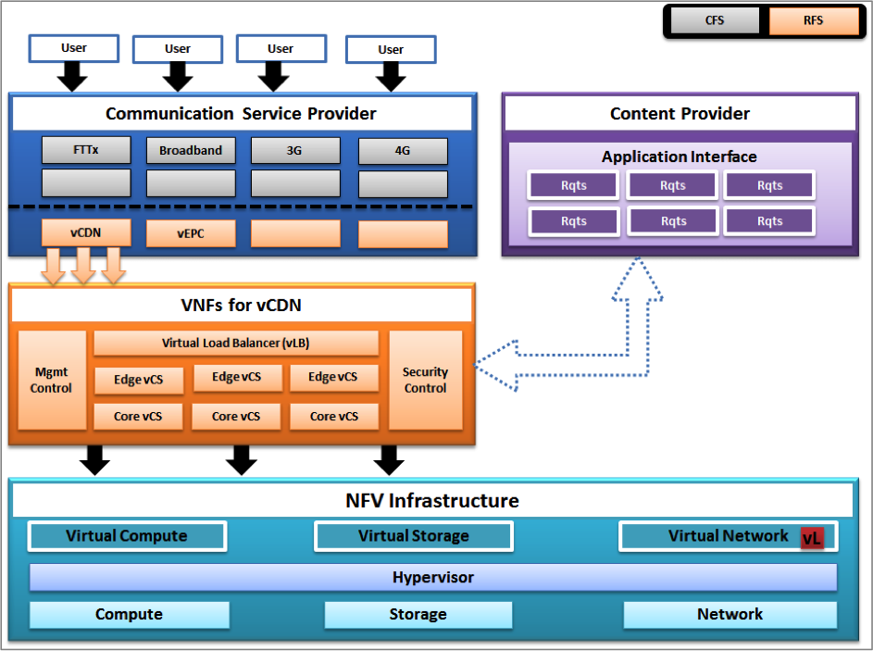
Figure 7. Introduction of the NetworkService Hierarchy
Below is an example how the NerworkService and NetworkFunction classes, together with their new relationships, can be instantiated (note that the parts in the grey box are example instantiation of the model and not part of the Information Framework).
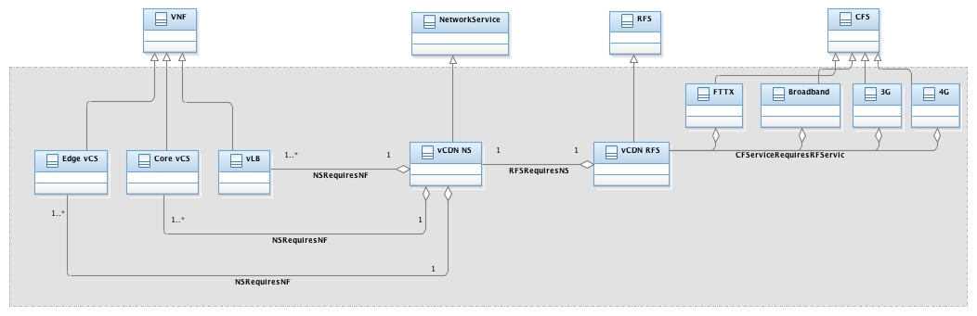
Figure 8. Introduction of the NetworkService Hierarchy

Graphs

This section introduces the addition of the Graph hierarchy to Frameworx.

Problem Statement
Graphs are powerful topological concepts that can be used to model a large variety of topological relations between entities ranging from dependencies to connectivity.
The closest concept that can be found are the Network ABE and the Converged Network ABE, however they are both specialized for expressing networking connectivity. Therefore, a way to express more general topological relationships needs to be added to the model.
NFV is introducing the notion of VNF Forwarding graphs which to be properly represented need the concept of graph as a topological tool.

Proposed Resolution
Creation within the Information Framework of a Topology ABE within the CBE domain and the introduction of hypergraphs (a generalization of graphs) composed of vertices and directed edges within this ABE in a way that allows to express any topological relationship that can be represented by a graph between any entities deriving from Entity within SID. Such Topology ABE could later be enriched with other topological concepts like sets.

Graph Proposal Within the Topology ABE
The following diagram expresses the general and core relations constituting a graph.
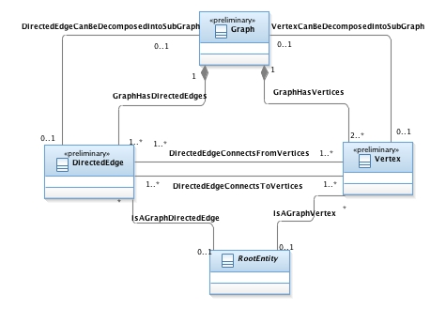
Figure 9. Introduction of the NetworkService Hierarchy

A Graph is composed of Directed Edges and Vertices as expressed by the GraphHasDirectedEdges and GraphHasVertices composition relations.
A DirectedEdge connects two set of vertices within a graph in a directed fashion, allowing the expression of asymmetric relationtions. Therefore it has two relationships towards vertices: one towards its set of “Origin” Vertices of the Directed Edge expressed by DirectedEdgeConnectsFromVertices and the other one towards its set of “destination” vertices expressed by EdgeConnectsToVertices.
Note: Since a directed edge in this proposal connects more than a pair of vertices, this proposal is more of a hypergraph with hyperedges from a pure mathematical and topological perspective. However, for the ease of language, we are using graphs and edges instead of hypergraphs and hyperedges.
Furthermore, a DirectedEdge can be decomposed into a sub graph as expressed by the relation DirectedEdgeCanBeDecomposedIntoSubGraph.
Similarly a Vertex can be decomposed into a sub graph as expressed by the relation VertexCanBeDecomposedIntoSubGraph.
Since the intent is to be able to use graphs to express any type of topological relation between any most entities, the IsGraphVertex relation expresses that any RootEntity (and therefore any derived entity) can be a vertex for a graph and the IsGraphDirectedEdge relation expresses that any Entity (and therefore any derived entity) can be a directed edge for a graph.

Using Graphs to Model Forwarding Graphs
Subclassed from Graph, two new entities are proposed:
- AdjacencyGraph are proposed to be graphs expressing an adjacency requirement or property, independently from how this is realized which would be expressed using a connectivity Graph
- ConnectivityGraph are proposed to be graphs expressing the realization of adjacency.
Two other subclasses from AdjacencyGraph are proposed:
- ForwardingGraph to model the adjacency requirements and properties between NetworkFunctions and NetworkServices composing a NetworkService
- NFInternalTopology to model the internal connectivity of a NetworkFunction.
This is illustrated in the following diagram:
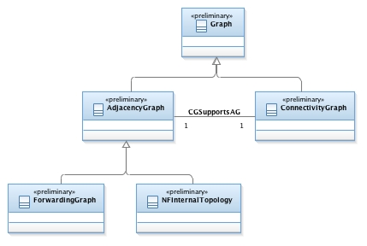
Figure 10. Subclasses of the Graph Class
As explained in the class hierarchy discussion, the forwarding graphs for a NetworkService as well as the internal topology of a NetworkFunction are modeled as subclasses of adjacency graph as depicted in the following diagrams:
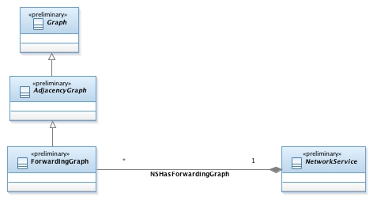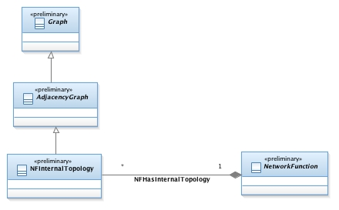
Figure 11. AdjacencyGraph, as Used by NetworkService and NetworkFunction
The InternalTopology has a composition relationship to the NetworkFunction modeling the fact that the internalTopology of NFs cannot be shared between NFs while the FowardingGraph has an aggregation pattern since forwarding graphs can be shared between NetworkServices.
Last but not least, the realization or support of an adjacency graph is modeled through the CGSupportsAG relation.
With this proposal, a Forwarding Graph in the ETSI/NFV meaning is modeled as an adjacency graph while the supporting Network Forwarding Paths are represented as paths within the supporting connectivity graph.

New Class Definitions
This section provides definitions for all new classes in the NetworkService hierarchy that are introduced in the ZOOM model.

Graph
The properties and description of a Graph class are as follows:
Properties: preliminary, Abstract
Description: A Topological Construct composed of a set of vertices connected by Directed Edges.

Vertex
The properties and description of a Vertex class are as follows:
Properties: preliminary, Abstact
Description: A node within a graph.

DirectedEdge
The properties and description of a DirectedEdge class are as follows:
Properties: preliminary, Abstact
Description: A relation within a Graph between a set of origin vertices toward a set of destination vertices.

AdjacencyGraph
The properties and description of an AdjacencyGraph class are as follows:
Properties: preliminary, Abstract
Description: A Graph expressing an adjacency requirement or property, independently from how this is realized.

ConnectivityGraph
The properties and description of a ConnectivityGraph class are as follows:
Properties: preliminary, Abstact
Description: A Graph expressing the realization of adjacency.

FowardingGraph
The properties and description of a ForwardingGraph class are as follows:
Properties: preliminary, Concrete
Description: An Adjacency Graph expressing the adjacency requirements between the Connection points of the NetworkFunctions composing a NetworkService.

NFInternalTopology
The properties and description of an NFInternalTopology class are as follows:
Properties: preliminary, Concrete
Description: An Adjacency Graph expressing the adjacency requirements between the internal connection points of the VNF Components.

New Association Definitions
This section provides definitions for all new associations in the NetworkService hierarchy that are introduced in the ZOOM model.

GraphHasVertices
This association expresses the fact that a Graph is a collection of Vertices.

GraphHAsDirectedEges
This association expresses the fact that a Graph is a collection of Directed Edges connected Vertices.

DirectedEdgeCanBeDecomposedIntoSubgraph
This association expresses the fact that a Directed Edge within a graph can be itself further decomposed into a complete sub-graph.

VertexCanBeDecomposedIntoSubgraph
This association expresses the fact that Vertex within a graph can be itself further decomposed into a complete sub-graph.

DirectedEdgeConnectsFromVertices
This association represents the set of originating vertices of a Directed Edge of a Graph.

DirectedEdgeConnectsToVertices
This association represents the set of Destination vertices of a Directed Edge of a Graph.

IsAGraphDirectedEdge
This association expresses the fact that any entity can be used an a Directed Edge within a Graph.

IsAGraphVertex
This association expresses the fact that any entity can be used an a Vertex within a Graph.

CGSupportsAG
This association expresses the fact that an adjacency Graph which is expressing intent is realized by a Connectivity Graph representing actual and concrete connectivity.

NSHasForwardingGraph
This association expresses the fact that a NetworkService requires Adjacency between the connections points of the NetworkFunctions composing that NetworkService.

NFHasInternalTopology
This association expresses the fact that a VNF requires Adjacency between the internal connections points of the VNF Components composing that VNF.

Example
The following section illustrates how the proposed notion of graphs can be used to properly model and represent the notions of Virtual NetworkFunction Forwarding graphs.
Section 6.5 of ETSI/NFV/GS NFV-MAN 001 [9] illustrates the usage of forwarding graphs and forwarding paths within NetworkServices and VNFs. With the proposal exposed above, the set of Forwarding Paths and Connection points together with their respective relationship is exposed using directedges and vertices within forwarding graphs as per the following figure:
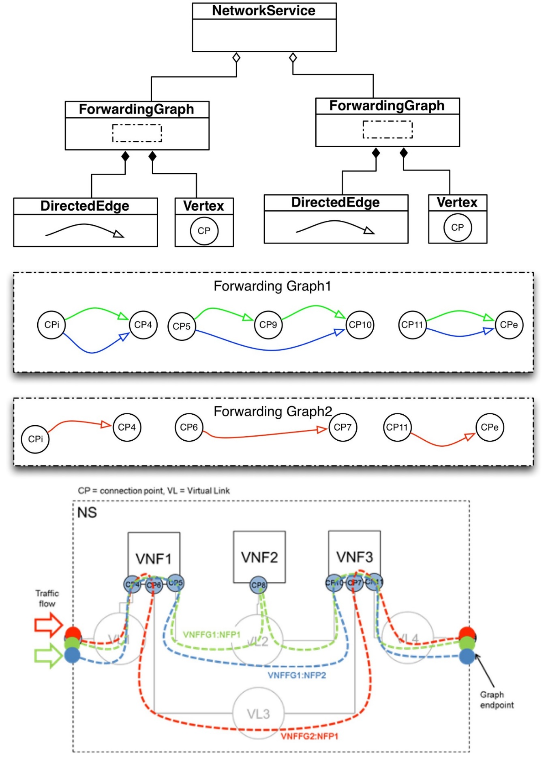
Figure 12. AdjacencyGraph, as Used by NetworkService and NetworkFunction

Catalog
This section describes the integration of the ZOOM Catalog model with the existing SID catalog model.

Problem Statement
There is a need to enhance the current Catalog model in Frameworx.
New approaches, such as NFV and SDN, require a dynamic and complex integration of different actors in the ecosystem (e.g., suppliers, partners, and different groups within the enterprise). Catalogs can be used to define what elements are offered by an actor. Due to the dynamic nature of the ecosystem, it is important that the Catalog model can support:
- A wide variety of Catalog types (i.e., the static classification of Catalog types is not sufficient)
- a wide variety of content that can be dynamically defined and configured (i.e., the type of items that can be included within a Catalog should not be statically predefined)
- different content should be able to be easily added and removed
- extensible types and content without having to redefine the model
- Catalog and CatalogItem types should be able to be managed using policy rules [7].

Constraints
It is important to be able to add this enhancement without disrupting the existing Frameworx Catalog model.

Proposed resolution
This section describes the current Frameworx model, and how the ZOOM Catalog model is integrated into it without causing any disruption to the Frameworx model.

Current Frameworx Model
The current Catalog model is shown in Figure 13 below.

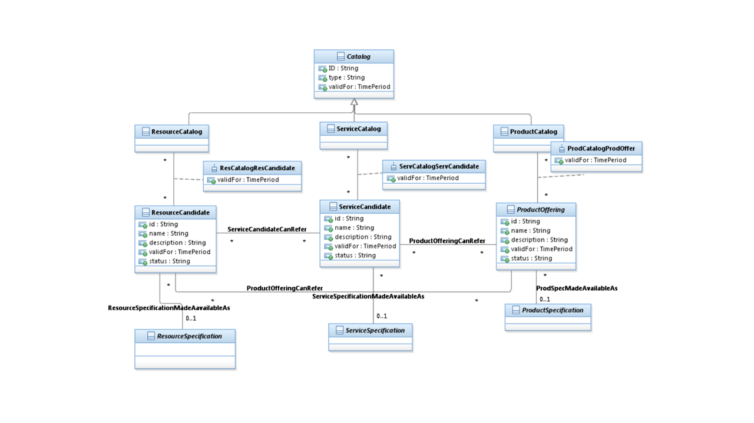

Figure 13. Existing Frameworx Catalog Model
This model does not meet the following requirements in the Problem Statement:
- there are three pre-defined types of Catalogs
there are three pre-defined types of content
- there is no simple way to manage the Catalog or the content of a Catalog using policy rules
In addition:
- The existing model uses associations, instead of aggregations. This means that Catalog content is only associated with a type of Catalog, and does not form a whole-part relationship (more formally, there is no way to add and remove content from a Catalog)
- There is no difference, syntactically or semantically, between a ProductCatalog, a ServiceCatalog, and a ResourceCatalog as defined in the above model

Enhanced Frameworx Model
There are four steps to enhancing the Frameworx model. None of these four steps require any change to the existing Frameworx model - they simply add functionality to the Catalog class.

Step 1: Adding the Ability to Add and Remove Catalog Items
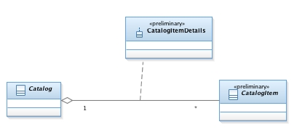
Figure 14 shows the first step of enhancing the Frameworx Catalog model.
Figure 14. Enhanced Catalog Model
Figure 14 defines an aggregation called HasCatalogItems. This aggregation defines the set of zero or more CatalogItems that are contained in this Catalog. Individual CatalogItems can be dynamically added to or removed from a Catalog by instantiating (or deleting) an instance of the HasCatalogItems aggregation. Note that both Catalog and CatalogItem are defined as abstract. This gives the developer freedom to express the objects and relationships of the Catalog model as information model elements while not restricting how the information model is mapped to a data model.
Note that the above approach has not altered the existing Frameworx model in any way. Specifically, the only change in this part of the proposed enhancement is to define one new class (CatalogItem) and one new aggregation (HasCatalogItems). The rest of the existing Catalog model is not changed.

Step 2: Adding the Ability to Manage Catalog Content Using Policy Rules

The second step in enhancing the Frameworx Catalog model is to introduce policy rules for governing what types of CatalogItems can be added to which Catalogs. This is shown in Figure 15. (TR235 [10] describes policy management in more detail.)
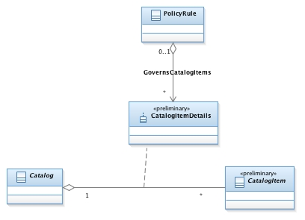

Figure 15. Using PolicyRules to Govern CatalogItems
In Figure 15, the HasCatalogItems aggregation has been realized as an association class, called CatalogItemDetail. This class defines the semantics of the HasCatalogItems aggregation. For example, one or more attributes of the CatalogItemDetail association class can be used to represent which CatalogItems are contained in which Catalog.
The GovernsCatalogItems aggregation defines the set of PolicyRules that are used to govern the values of the attributes of the CatalogItemDetail attributes. In this way, PolicyRules can manage which CatalogItems are contained by which Catalogs through governing the values of the CatalogItemDetail attributes.
Note again that the above enhancement does not affect the existing Frameworx Catalog model in any way. Rather, this reuses the existing Catalog class, and adds additional functionality to it to meet the requirements specified in the Problem Statement at the top of this page.

Step 3: Adding the Ability to Dynamically Define Types of Catalogs
The third step in enhancing the Frameworx Catalog model is to enable different types of Catalogs to be defined. The existing Frameworx model has three pre-defined static types of Catalogs (ProductCatalog, ServiceCatalog, and ResourceCatalog). These three Catalog types were defined using inheritance. Clearly, we do not want to keep adding multiple subclasses to Catalog, as this rapidly becomes unmanageable and results in class explosion. In addition, if the existing Frameworx patterns were followed, then many additional classes and relationships would have to be added. For example, suppose a new class VNFCatalog was added as a subclass of Catalog. Then, following the existing Frameworx patterns, the following would need to be added:
- a VNFCandidate class
an association between a VNFCatalog and a VNFCandidate class
an association class (VNFCatalogVNFCandidate) that realizes the above association
a VNFSpecification class
- an association between a VNFSpecification and a VNFCandidate class
This set of five model elements is repeated for every new subclass of Catalog.
Instead, the Decorator pattern can be used to dynamically define and assemble new types of Catalogs. This is shown in Figure 16.
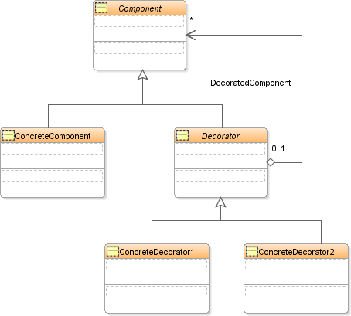

Figure 16. Using the Decorator Pattern to Dynamically Add New Catalog Types
The Decorator pattern is an established software pattern (circa 1995, and used extensively in DEN-ng) that enables additional responsibilities to be dynamically attached to an object. It is often used as a flexible alternative to subclassing. In this definition, the term "responsibility" is a reference to a fundamental principle of object-oriented programming, called the single responsibility principle (see Appendix 1). It is also known as the Wrapper Pattern. Basically, instead of using inheritance to statically create new types (classes) of objects, it uses composition to dynamically combine smaller objects into more robust ones.
In Figure 16:
- a Component defines the interface for objects that can have responsibilities added dynamically
a ConcreteComponent defines an object to which additional responsibilities can be attached dynamically (there can be multiple such classes; Figure 4 shows one for simplicity)
a Decorator defines an interface that conforms to the Component's interface
- a ConcreteDecorator adds responsibilities to the ConcreteComponent

In Java, as well as other types of programming language, the above pattern works through object wrapping. Basically, all subclasses of the Decorator class are of the same type as Component (and therefore ConcreteComponent). They all have the same interface. This allows each Decorator subclass to add its attributes and behavior to the object (i.e., ConcreteComponent, or any of its subclasses) that it is wrapping. This works because any Decorator subclass has the same supertype as ConcreteComponent (and its subclasses). More importantly, a Decorator object can add its own behavior, before and/or after, it delegates to the object it is decorating. This provides a very flexible and completely dynamic mechanism to:
- add or remove behavior to/from an object, and more importantly
- ensure that objects are constructed using the minimum amount of features and functionality required (see Appendix 2 for an example)
Note that the Decorator pattern is used extensively in Java. In addition to windowing functionality (see Appendix 1), the Java I/O classes use the Decorator pattern.
Figure 17 shows the Decorator pattern applied to the Catalog class. This enables different types of Catalogs to be dynamically composed at runtime.
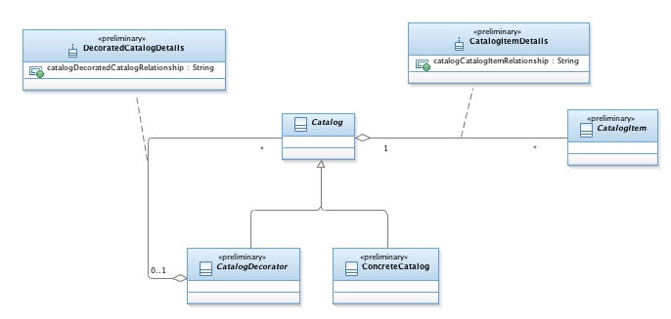
Figure 17. Catalog Decorators

Step 4: Adding the Ability to Dynamically Define Types of Catalog Content
This step is identical to step 3 above; all that is necessary is to apply the Decorator pattern to the CatalogItem class.
Figure 6 shows the Decorator pattern applied to the CatalogItem class. This enables different types of CatalogItems to be dynamically composed at runtime.

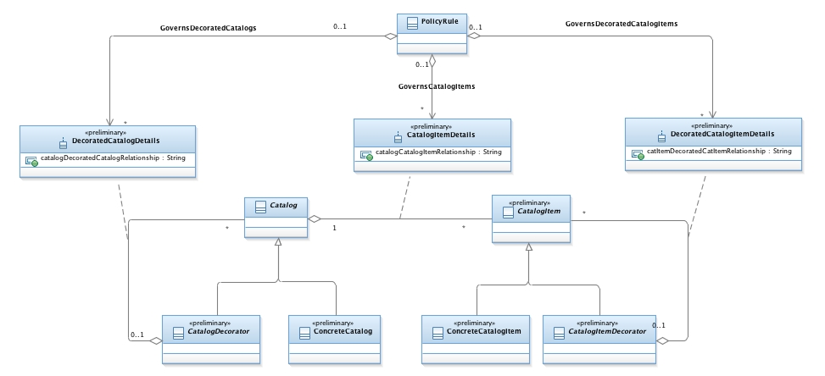

Figure 18. CatalogItems Decorators

New Class Definitions
This section provides definitions for all new classes in the Catalog hierarchy that are introduced in the ZOOM model. Note that the Catalog class is reused from Frameworx.

CatalogItem
The properties and description of a CatalogItem class are as follows:
Properties: preliminary, Abstract
Description: A CatalogItem defines the type of objects that can be contained in a catalog.

CatalogDecorator
The properties and description of a CatalogDecorator class are as follows:
Properties: preliminary, Abstract
Description: This class, along with ConcreteCatalog, implement the decorator pattern. This class is the superclass of objects that will decorate the ConcreteCatalog Class.
The Decorator Partern enables additional responsibilities to be dynamically attached to an object. It uses composition to dynamically “wrap” object instances, instead of inheritance.

ConcreteCatalog
The properties and description of a ConcreteCatalog class are as follows:
Properties: preliminary, Abstract
Description: This class, along with CatalogDecorator, implement the decorator pattern. This class is the target object that subclasses of CatalogDecorator will wrap.
The Decorator Partern enables additional responsibilities to be dynamically attached to an object. It uses composition to dynamically “wrap” object instances, instead of inheritance.

CatalogItemDecorator
The properties and description of a CatalogItemDecorator class are as follows:
Properties: preliminary, Abstract
Description: This class, along with ConcreteCatalogItem, implement the decorator pattern. This class is the superclass of objects that will decorate the ConcreteCatalog Class.
The Decorator Partern enables additional responsibilities to be dynamically attached to an object. It uses composition to dynamically “wrap” object instances, instead of inheritance.

ConcreteCatalogItem
The properties and description of a ConcreteCatalogItem class are as follows:
Properties: preliminary, Abstract
Description: This class, along with CatalogItemDecorator, implement the decorator pattern. This class is the target object that subclasses of CatalogItemDecorator will wrap.
The Decorator Partern enables additional responsibilities to be dynamically attached to an object. It uses composition to dynamically “wrap” object instances, instead of inheritance.

New Association Definitions
This section provides definitions for all new associations in the NetworkService hierarchy that are introduced in the ZOOM model.

GovernsCatalogItems
This association defines the semantics of which CatalogItems can be contained in which Catalogs. This is done by using a set of PolicyRules that can edit the attributes within the CatalogItemDetails association class, thereby changing how a particular CatalogItem is related to a given Catalog.

GovernsDecoratedCatalogs
This association defines the semantics of which CatalogDecorators can modify, or wrap, which ConcreteCatalogs. This is done by using a set of PolicyRules that can edit the attributes within the DecoratedCatalogDetails association class, thereby changing how a particular CatalogDecorator is related to a particular ConcreteCatalog.

GovernsDecoratedCatalogItems
This association defines the semantics of which CatalogItemDecorators can modify, or wrap, which ConcreteCatalogItems. This is done by using a set of PolicyRules that can edit the attributes within the DecoratedCatalogItemDetails association class, thereby changing how a particular CatalogItemDecorator is related to a particular ConcreteCatalogItem.

CatalogItemDetails
This association class defines the semantics of of how CatalogItems and Catalogs are related. The attribute catalogCatalogItemRelationship defines any restrictions on which CatalogItem can be contained by which Catalog.

DecoratedCatalogDetails
This association class defines the semantics of of how CatalogDecorator and Catalog are related. The attribute catalogDecoratedCatalogRelationship defines any restrictions on which Catalogs can be decorated by which CatalogDecorators.

DecoratedCatalogItemDetails
This association class defines the semantics of of how CatalogItemDecorator and CatalogItem are related. The attribute catItemDecoratedCatItemRelationship defines any restrictions on which CatalogItems can be decorated by which CatalogItemDecorators.

Examples
The following two examples illustrate the use of the Catalog and CatalogItem class hierarchies.

Creating a VNFCatalog
A VNFCatalog is a fundamental requirement of ETSI NFV compliance. However, the ETSI NFV definition of a VNF Catalog is not specific, so vendor and provider implementations vary widely. Specifically:
- VNF does NOT have to be offered as a Product
A VNF typically consumes Resources, but does not have to expose them
- A VNF typically produces Services, but does not have to expose them
Therefore, a VNFCatalog is not a type of ProductCatalog; neither is it a type of ResourceCatalog or ServiceCatalog.
Using the Decorator pattern, we can easily customize the definition of a VNFCatalog to suit the operator (or even the application).

Dynamic NFV Catalog Federation
The capability to define and federate dynamically generic catalogs containing items belonging to both Service and Resource domains is illustrated in the Dynamic NFV Catalog Federation User Stories developed in ZOOM Theme 3 (cf http://projects.tmforum.org/wiki/pages/viewpage.action?pageId=33948076), from which the following figure is extracted:
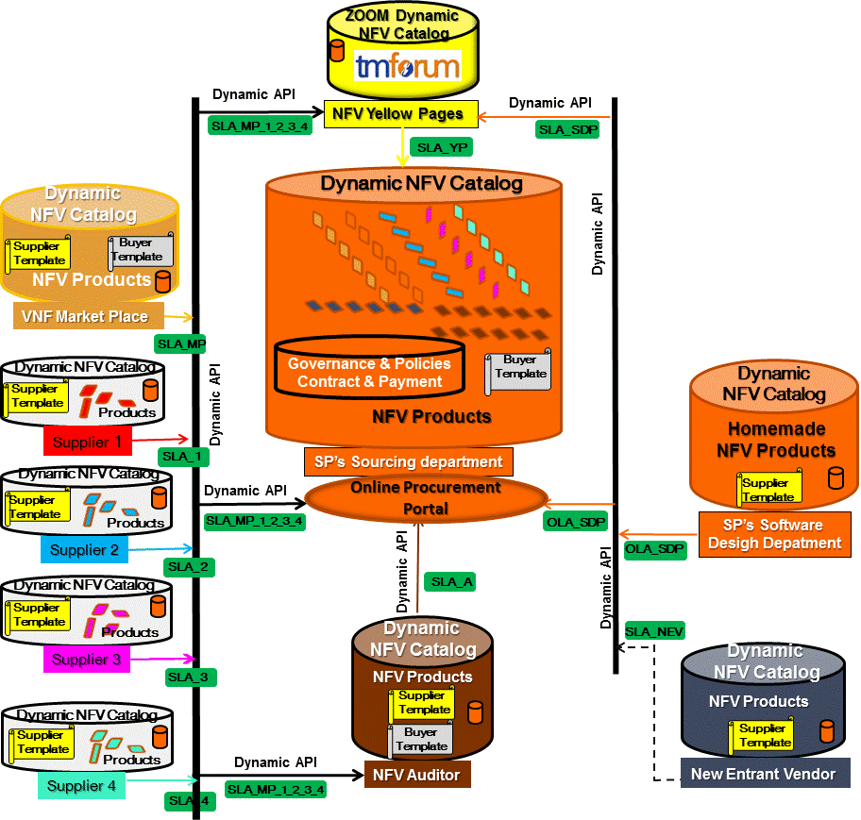

Figure 19. Federated dynamic NFV Catalogs (high level architecture)

Summary

The Frameworx Catalog design has been enhanced in four fundamental ways WITHOUT having to change any of the existing design:
- the model can define new types of Catalogs, and reuse existing types of Catalogs, dynamically at runtime
the model can dynamically define and configure catalog content
the model can dynamically add and remove catalog content without disturbing the rest of the model
- the model can govern which type of Catalog, and which types of CatalogItems, are made available using policy rules

Event
This section describes the integration of the ZOOM Event model with the existing SID catalog model.

Problem Statement
Events are fundamental concepts to modern systems. In fact, a genre of systems, called event-driven systems, focuses on this concept. This is supported by a particular programming paradigm, called event-driven programming. Many of the Catalyst programs have been, and are currently implementing, event-driven systems. There is a need for legacy, as well as SDN and NFV-based systems, to also use this technology. Since the current version of the SID lacks such a generalized concept, it is proposed to add this feature to Frameworx 15.0.

Background
This section defines the terminology used for Events.

Event Definition
An Event represents a significant occurrence that contains data and/or knowledge pertaining to a specific context. An Event carries information that may be used by one or more Entities to evaluate whether an Entity should execute some behavior or not (e.g., whether a fault occurred, whether something should be reconfigured or monitored, or in general, whether a state transition should be made or not). The information may be the Event itself (e.g., sending an acknowledgement) or the Event may carry one or more objects (called a payload) that provide data, commands, or other information to be acted on.

Event Usage
Events are typically used when external activity that needs to be acted on can occur asynchronously. The activity can range from being purely informational in nature to requiring a set of actions (with optional acknowledgements). An event-driven system can be thought of as a program that runs a loop that waits for Events to occur. When an Event occurs, then the system may optionally collect data about the Event (e.g., time of day or other contextual information), followed by optionally creating one or more actions in response to the occurrence of the Event.
Hence, three important concepts are involved in representing Events, each of which is modeled as a separate object:
- the occurrence of the Event (this will be called an EventOccurrence)
data about the EventOccurrence (this will be called an EventRecord)
- information associated with the EventRecord (this will be called an EventPayload)

Requirements of the Event Model
The following are a set of requirements that the Event model must represent:
- Since Events are just occurrences in time, they are by definition not manageable.
- The occurrence of an Event may (but does not have to) have an associated realization that can provide information and/or drive actions to be taken. Therefore, we model the realization of one or more Event occurrences separately from the information conveyed and/or actions caused by these Event occurrences.
- ManagedEntities can send and receive Events.
- Information associated with an EventOccurrence can be operated on (e.g., suppressed, aggregated, or filtered).
- An Event has a distinct identity, so that different instances of the same Event can be distinguished from each other.
- An EventRecord may have associated information with it (e.g., a payload). Therefore, we differentiate between an EventRecord and an EventPayload.
- An EventPayload contains manageable information.
- It would be convenient to categorize Events to simplify their processing.
- EventRecords can be grouped together.
Requirement #1 says that an Event is not manageable. We choose the name EventOccurrence to enforce that, and subclass it from InformationElement, since it is not manageable.
Requirement #2 says that a separate class should be created for operating on the consequences of one or more EventOccurrences. This class is named an EventRecord, and can aggregate one or more EventOccurrences.
Requirement #3 means that an EventOccurrence is subclassed from InformationElement, but an EventRecord is subclassed from ManagedResource.
Requirement #4 says that information contained in an EventRecord can be managed. This means that the EventRecord as well as information that it may contain should each be manageable (see Requirement #6).
Requirement #5 implies that both EventOccurrence as well as EventRecord require some way to identify object instances. In other words, they are objects that have distinct identities and can (optionally) be persisted. This means that they should both be represented as a type of Entity (instead of, for example, a type of Metadata).
Requirement #6 implies that a separate object (which we name EventPayload) is required to contain the payload associated with an EventRecord. In addition, an EventRecord may contain zero or more EventPayloads.
Requirement #7 implies that an EventPayload should also be subclassed from ManagedResource.
Requirement #8 means that EventOccurrences, EventRecords, and EventPayloads may each have associated Metadata that can be used to provide descriptive and/or prescriptive information. Note that Metadata is the superclass for representing concepts that do not necessarily require representation as objects with distinct identities and lifecycles.
Requirement #9 means that the composite pattern should be used to construct collections and hierarchies of EventRecords.

Proposed Resolution
As stated above, Events consist of two parts: (1) the Event itself, which is a time-based notification that something happened, and (2) optional data or knowledge that is associated with the occurrence of the Event. Since these two aspects are fundamentally different, it is proposed to model Events as two objects within an new Event ABE within the Common Business Entities Domain:
- a class called EventOccurrence, which models the generation of an Event at a particular moment in time, and
- a class called EventRecord, which represents a managed object containing information associated with the EventOccurrence.
This is shown in the following diagram.
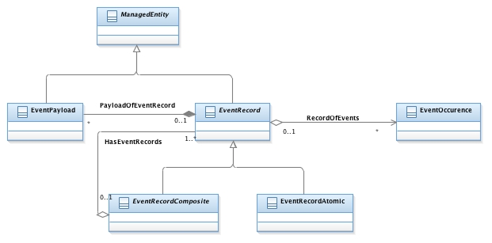
Figure 20. Event Model.
The EventRecord abstract class is the central piece of the model. It represents an aggregation of zero or more EventOccurrences. It can optionally contain associated information, captured in zero or more occurrences of the EventPayload class. An EventRecord can be a single, stand-alone entity (which is represented by an EventRecordAtomic class), or a hierarchy of entities (which is modeled using an EventRecordComposite class). Note that EventOccurrence and EventPayload are both concrete classes, as are the child classes of EventRecord.
Furthermore, an EventRecord can aggregate zero or more EventPayload objects.

New Class Definitions
This section provides definitions for all new classes in the Event hierarchy that are introduced in the ZOOM model.

EventOccurrence
The properties and description of an EventOccurrence class are as follows:
Properties: preliminary, Abstract
Description: An EventOccurrence models the generation of an Event at a particular moment in time.

EventRecord
The properties and description of an EventRecord class are as follows:
Properties: preliminary, Abstract
Description: An EventRecord represents an aggregation of zero or more EventOccurrences.

EventRecordComposite
The properties and description of an EventRecordComposite class are as follows:
Properties: preliminary, Abstract
Description: An EventRecordComposite is a collection of EventRecordAtomic and EventRecordComposite objects.

EventRecordAtomic
The properties and description of an EventRecordAtomic class are as follows:
Properties: preliminary, Concrete
Description: An EventRecordAtomic is a unitary, single EventRecordAtomic object.

EventRecordPayload
The properties and description of an EventRecordPayload class are as follows:
Properties: preliminary, Concrete
Description: An EventRecordPayload captures optional information associated with an EventRecord.

New Association Definitions
This section provides definitions for all new associations in the Event hierarchy that are introduced in the ZOOM model.

HasEventRecords
This association expresses the fact that an EventRecordComposite is a collection of EventRecords.

EventRecordPayload
This association expresses the aggregation of zero or more EventPayload objects into an EventRecord object.

EventRecordPayload
This association represents the aggregation of zero or more EventOccurrence objects into an EventRecord object.

Examples
The following are two examples of using the Event class hierarchy.

Events That Do Not Need Additional Information
Certain types of Events, such as temporal events, do not need additonal information. Specifically, they can be represented using simply an EventOccurrence, and do not need EventRecords or EventPayloads. A simple example is the changing of time (e.g., 17:59 to 18:00), which has a different cost associated with it.

Events That Do Need Additional Information
Most types of Events do need additional information. Examples include Events from the GUI system, logon/logoff, and alarm events.
For example, a GUI system typically generates Events for different types of actions performed by the user (e.g., key up, key down, mouse up, mouse down, and so forth). For each of these Events, associated information may be required to properly process the Event. Continuing the example, a key up or key down event must carry an indication of the specific key pressed or released. Similarly, a mouse up or mouse down event must define which mouse button was clicked, and optionally, the coordinates where the mouse was clicked.
Both of these types of Events may be modeled by an EventRecord, which combines the occurrence of the particular Event with its required contextual information.
As an additional example, messages sent on a publish-subscribe bus may have a set of common attributes and an optional attachment. In this example:
- An EventOccurrence defines when the message was sent
An EventRecord contains one or more EventOccurrences that contain common attributes; the set of EventOccurrences could optionally be processed according to one or more functions (e.g., filtered and correlated) before they were added to the EventRecord
An EventPayload contains additional context for the EventRecord (in this case, the attachment)

Summary
This document has described an extensible mechanism for modeling Events using three objects: an EventOccurrence, an EventRecord, and an EventPayload. An EventOccurrence is simply a significant occurrence in time, and hence is not manageable. Thus, a second class, called EventRecord, is defined to aggregate one or more EventOccurrences and treat them as a separate manageable object. An EventRecord can optionally contain associated information generated by the system being managed and/or the management system, in the form of a set of EventPayloads.

Appendix A: The Single Responsibility Principle
The Single Responsibility Principle states that every class should have responsibility over one, and only one, function provided by the software system and that this responsibility should be entirely encapsulated in the class. For example, imagine a Catalog class that has the following:
- add CatalogItem
remove CatalogItem
configure CatalogItem
arrange CatalogItems (e.g., organize alpha-numerically)
- print all CatalogItems
This is a poor design, as the Catalog class can now change for very different reasons, including because its content changed, its configuration changed, and its cosmetic appearance changed. For example, if the print method called the arrange method, and someone changed the arrange method, then there is a chance that the printing function will break. A design using the single responsibility principle would separate this into separate items.

Appendix B: Decorator Pattern Examples
This appendix provides a simple example of why the Decorator pattern is used so often.
This example illustrates the power of the Decorator pattern, and has nothing to do with Catalog functionality. However, it does represent how many GUI toolboxes operate to provide flexible GUI component behavior.
Suppose there is a GUI component called Window. A window can have many different types of features, such as horizontal and/or vertical scrollbars, borders, control buttons, and a title. It can even have different types of behavior (e.g., is it modal or not).
A bad way of building this functionality would be to have one subclass for every combination of features that a Window had. For example, if there were five types of borders, then just to have a choice of a window with or without five different types of borders and with or without two types of scrollbars yields 24 Windows:
- 1 window without any type of border or scrollbar
1 window with a horizontal scrollbar, but no vertical scrollbar or border
1 window with a vertical scrollbar, but no horizontal scrollbar or border
1 window with both a horizontal and a vertical scrollbar, but no border
5 windows, one of each type of border; each window has no horizontal scrollbar and no vertical scrollbar
5 windows, one of each type of border; each window has a horizontal scrollbar but no vertical scrollbar
5 windows, one of each type of border; each window has no horizontal scrollbar but does have a vertical scrollbar
- 5 windows, one of each type of border; each window has both a horizontal scrollbar and a vertical scrollbar
THIS IS 24 SUBCLASSES!
Worse, if we now add a title as a widget, then the addition of that one, single feature more than DOUBLES the number of classes required!
In addition, the client must know about each of the 24 above types of window, and then choose one STATICALLY to instantiate. The client cannot control how and when to add features or behavior to the Window.

Appendix C: List of References Used in This Document
The following materials are referenced by this document.
- TM Forum, ZOOM WG Charter, February, 2014
- http://www.lightreading.com/ethernet-ip/routers/deutsche-telekom-a-software-defined-operator/d/d-id/706099
- http://www.opennetsummit.org/archives/apr12/agarwal-saha-mon-datacenters.pdf
- U. Hölzle, “OpenFlow @ Google”, ONS 2012 Keynote
- http://www.cisco.com/c/en/us/solutions/service-provider/evolved-services-platform/index.html
- http://www.cisco.com/c/en/us/solutions/data-center-virtualization/application-centric-infrastructure/index.html
- J. Strassner, “Policy Based Network Management”, Morgan Kaufman Publishers, ISBN 978-1558608597, Sep 2003
- TM Forum, TR234, https://collab.tmforum.org/sf/go/doc26303?nav=1
- http://www.etsi.org/deliver/etsi_gs/NFV-MAN/001_099/001/01.01.01_60/gs_NFV-MAN001v010101p.pdf
- TM Forum, TR234, https://collab.tmforum.org/sf/go/doc26313?nav=1

Appendix D: Administrative Information
This Appendix provides additional background material about the TM Forum and this document. In general, sections may be included or omitted as desired; however, a Document History must always be included.
- Administrative Information
Version History for this document is as follows:

Table D1. 1. Document History Information
Version | Date | Author | Description of Changes
V0.1 | 20150417 | John Strassner | Initial template creation
V0.2 | 20150417 | Jean-Marie Calmel | Added content for VirtualResource, NetworkFunction, and NetworkService
V0.3 | 20150417 | John Strassner | Added content for Catalog
V0.4 | 20150421 | Jean-Marie Calmel | Revised Figure 8
V0.5 | 20150422 | John Strassner | Final edits, ready for formal team review
V0.6 | 20150422 | John Strassner | Typos, added additional reviewers
V0.7 | 20150424 | John Strassner | Fixed page numbering and headers
V0.8 | 20150424 | John Strassner | Changed title of document as suggested by SID team
V1.0 | 20150430 | John Strassner | Approved by ZOOM Project Team
V1.0.1 | 20150515 | Alicja Kawecki | Updated cover, header, footer; formatting and style corrections
V1.0.2 | 20151110 | Alicja Kawecki | Updated cover and Notice to reflect TM Forum Approved status
V1.0.3 | 20160204 | Alicja Kawecki | Correction to original contributor list in Appendix

- Release History

Release Number | Date Modified | Modified by | Description of Changes
V0.5 | 20150422 | John Strassner | Final edits, ready for formal team review
V0.6 | 20150423 | John Strassner | Now into formal team review
V0.7 | 20150424 | John Strassner | Now into formal team review
V0.8 | 20150424 | John Strassner | Approved by Theme 4 Team
V1.0 | 20150430 | John Strassner | Approved by ZOOM Project Team

- Company Contact Details

Company | Team Member Representative(s)
Alcatel Lucent | Tanja De Groot
Ciena | Nigel Davis
Cisco | Joe Ruffles
EnterpriseWeb LLC | Dave Duggal
Ericsson | Kaj Jonasson
HP | Marc Flauw (editor of Frameworx model)
Huawei | John Strassner (co-editor)
NTT | Shingo Horiuchi
Oracle | Jean-Marie Calmel (co-editor)
Oracle | Fred Feisullin

Additional input was provided by the following people:
- Jenny Huang, AT&T
- Tayeb Ben Meriem, Orange
- Cliff Faurer, amkbcloud.com
- Babu Pawar, TechMahindra
- Kannan Ramachandran, TechMahindra
- Dave Milham, TM Forum
- Ken Dilbeck, TM Forum

